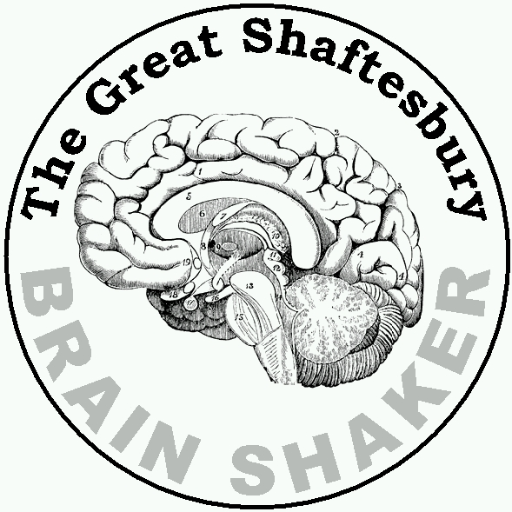
Happy Shoppers!
Decipher the cryptic clues to reveal 10 popular shops!

Example | More Copse than Forest ? | Littlewoods
 | A Boxing Partners Job ?
 | A Seasonal Paddock ?
 | Secure Routes ?
 | A Potent Narcotic ?
 | Quebec + Bravo, in reverse perhaps ?
 | Moisten Pebbles ?
 | After this maybe ?
 | Bill's ?
 | In Between ?
 | A Princess before Autumn ?

